FEC I - Student Handout

**Engineering Statistics I Homework**

Work these problems in class during a time determined by your professor, who will assist as needed. Continue to work on the problems as a homework and submit them in canvas. Use excel on this homework.

1. Determine the mean and standard deviation of the following five numbers, in meters:

3.0, 6.0, 2.0, 5.0, 5.0. Use DATA/Text to Columns to import into Excel.

MEAN: 4.2

STANDARD DEVIATION: 1.5

1. Create a column chart with one standard deviation error bars for the samples shown in Table 1.

Table 1: Strength of Materials A and B

|  |  |  |
| --- | --- | --- |
| **Material** | **Mean (Pa)** | **Standard Deviation (Pa)** |
| A | 50 | 10 |
| B | 60 | 20 |

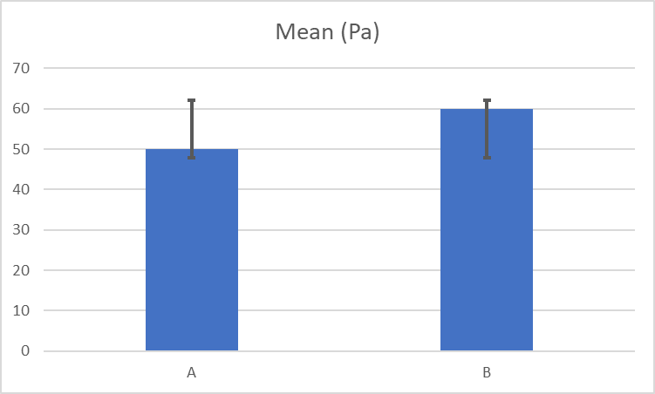

1. Create a scatter chart with Voltage on the x-axis, Power on the primary y-axis, and Speed on the secondary y-axis using the data in Table 2. Fit a linear regression to Speed regressed on Voltage. Fit a power regression to Power regressed on Voltage. It is a coincidence that 'Power' in Watts follows a 'power' relationship (Y = aXb) in this example.

Table 2: Chattanooga Train Powered by Train Set Power Pack

|  |  |  |
| --- | --- | --- |
| **Voltage (V)** | **Speed (cm/s)** | **Power (W)** |
| 3.4 | 7.8 | 0.54 |
| 5.1 | 14.3 | 0.97 |
| 6.6 | 19.8 | 1.45 |
| 7.8 | 24.8 | 1.87 |
| 9.1 | 29.5 | 2.46 |
| 10.3 | 33.9 | 2.88 |
| 11.7 | 38.9 | 3.63 |
| 13.1 | 44 | 4.32 |
| 14 | 46.3 | 4.9 |

Last Revised - 7/1/2020 - JWE